 FFFFFFFF  FR FF

|  |
| --- |
| **CARATTERISTICHE TECNICHE/CARACTERISTIQUES TECHINIQUES**  **TECHNICAL CHARACTERISTICS/TECHNISCHE DATEN**  **CARACTERISTICAS TECNICAS** |

FFTTTFT20

L

L1

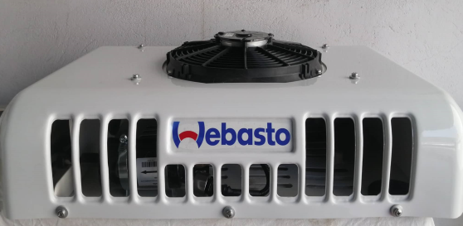 

H

H

W1

|  |
| --- |
| **Dimensione / Dimensions**  **Dimensions / Maß**  **Dimensión** |
| L1 | 655mm |
| W1 | 493mm |
| H11 | 147mm |
| http://www.autoera.lv/published/publicdata/JUKKASHOP/attachments/SC/images/weight.png | 10 |

|  |  |
| --- | --- |
| **Dimensione / Dimensions**  **Dimensions / Maß**  **Dimensión** | |
| L | 797mm | |
| W | 510mm | |
| H | 173mm | |
| http://www.autoera.lv/published/publicdata/JUKKASHOP/attachments/SC/images/weight.png | 18 |  |

|  |  |
| --- | --- |
| R134a | R404A |
| **Potenza figorifera**  **Puissance frigorifique**  **Cooling power**  **Kuhlerleistung**  **Potencia frigorifica** | **Potenza figorifera**  **Puissance frigorifique**  **Cooling power**  **Kuhlerleistung**  **Potencia frigorifica** | **Portata aria**  **Débit d’air**  **Air flow**  **Luftmenge**  **Capacidad aire** | **Volume cella**  **Volume du compartiment**  **Compartiment volume**  **Kuhlraum Volumen**  **Volumen camara** | **Assorbimento**  **Absorption**  **Rated power**  **Aufnahme**  **Absorcion** |
|  |  | m3/h | m3 | Amp |
|  |  |  |  |  |
| 1650w |  | 1430 | 8 | 14 |
|  | 1350w | 1430 | 5 | 14 |